The event is organised by Wexford Motor Club and will be held under the general competition Rules of MI (incorporating the provisions of the International Sporting Code of the F.I.A.) and in accordance with Appendix 80 and 81 of the current Motorsport Ireland Yearbook, copies of which are available on www.motorsportireland.com, and these supplementary regulations. All competitors who forward entry forms agree to be bound by these rules. Both hills count as round of the Naylor engineering Hillclimb & Sprint Championship 2014

MOTORSPORTS IRELAND PERMIT NO:14/050

LIST OF OFFICIALS
Motorsport Ireland Steward Dave Fitzgerald
Motorsport Ireland Safety Officer Ken Treacy
Clerk of the Course Brendan Harpur
Deputy COC Noel Moran
Club Steward Tommy Murphy
Club Safety Officer (sat) Joseph Kinsella
(sun)John Delaney
Chief Scrutinieer Jason Keogh
Chief Marshal Michael Brady
Scrutinieer MI Team
Event Secretary Brid Harpur Assistant Secretary Majella Whicham
Bike Marshal Kieran Merrigan
Paddock Marshal Pj Murphy
Timing & Results Cecil Orr & Team
Chief Medical Officer Dr. Mary Hooper
Ambulance Order of Malta (Wexford)
Rescue Sat Leinster Rescue
Rescue Sun Leinster Rescue

Event Venue: Sat 12th of April Poulfur Course length 1.55km ,Sun the 13th of April Ballygow Course length 2.070km

Entries Close: Tuesday the 8th of April

Entries are limited to 85 each day. Hence entries will be taken on a first come first served basis.

TIMETABLE BOTH DAYS
Optional Scrutiny on Friday the 11th at Neville’s pub in Fethard 7pm – 9pm
Mechanical and Document Scrutiny in the Paddocks on both mornings 8.00 am - 10.00a.m.
Driver’s briefing – Paddocks both mornings 10.10 a.m.
Road Closed Both Days 9.00 a.m. -6.00 p.m.
Practice Run Day 1 11.00 a.m.
1st Timed run approx on Day 1 12.30 p.m
Practice Run Day 2 11.30am
1st Timed Run approx. on Day 2 1.00pm
Our intention is to give a minimum of 3 timed runs each day.

Finish Approx on both days 5.00 p.m.

Definitions.
Production Saloon: Bodyshell as per originally manufactured. Modified Production Saloon: Bodyshell modified from originally manufactured but no section may be spaceframed. GT & Sports Car: Production and non production GT and Kit Cars. Turbo/supercharged: cc x 1.7 applies to classes 1, 2, 3A, 3B, 6, 8, 9.

Classes.
(1) Production saloons up to 1400cc.
(2) Production saloons from 1401cc up to 1650cc.
(3A) Production Saloons 1651 to 2050cc, Modified Production Saloons up to 2050cc, GT up to 1650cc and Sports Cars up to 1200cc.
(3B) Production/Modified Saloons and Rally Cars over 2050cc, GT Cars over 1650cc, Sports Cars 1201 to 2050cc and 4WD Rally Cars/Production Saloons.
(4) Classic Cars per HRCA regulations. (See Appendix 49) & FIA Appendix K.
(5) Formula Ford 1600 / Classic Formula Ford 1600 as per Ford Motorsport regulations & Formula Vee as MI appendix 45 regulations.
(6) 2050 Formula Libre. Single Seaters up to 2050cc having only one camshaft and Single Seaters up to 1650cc with two or more camshafts.
(7) Libre / Sports Cars Unlimited and all other 4 wheel drive cars.
(8) Rally cars up to 1650cc.
(9) Rally cars 1651cc to 2050cc.
Minimum of National B Speed Licence is required with the exception of competitors competing in classes 3, 6, 7 and 9 which are required to have a minimum of a National A Speed licence.THE ORGANISERS RESERVE THE RIGHT TO ADD ADDITIONAL CLASSES
ENTRY FEE €220 FOR BOTH DAYS €130 FOR ONE DAY

NO ENTERIES WILL BE TAKEN EITHER THE SATURDAY OR SUNDAY OF THE EVENT.
ENTRIES CLOSE ON TUESDAY 8th of April 2014
ENTRIES TO: Brid Harpur
Heavenstown
Murntown
Co. Wexford
Contact Number: 086-8403017 PHONE BETWEEN 7PM AND 9PM ONLY

ALL ENTRIES TO THE EVENT SECRETARY ONLY

REMEMBER TO BRING YOUR 2014 COMPETITION LICENCE AND VALID LOGBOOK WITH YOU
NO LICENCE....NO START NO LOGBOOK....NO START
Driver:
Only one person is allowed in a competition car at any time during the event, including the Paddock

Class Eligibility
The onus will be on the competitor to ensure that they have been entered in the correct class.
Please read the above classes carefully before you fill in your entry form.
Note: CARS BEING DOUBLE DRIVEN CAN ONLY ENTERED INTO ONE CLASS

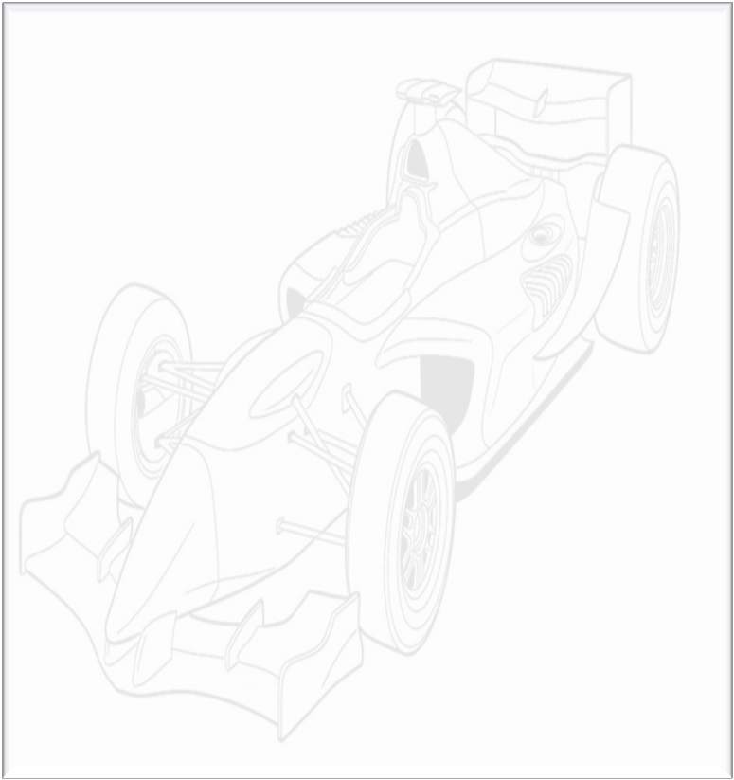

Double Drivers
Double drive cars must display a sticker provided by the organisers. The sticker should be a black ‘‘D‘‘on white background to be placed on top of the windscreen or middle of the bodywork in front of the driver for single seaters.

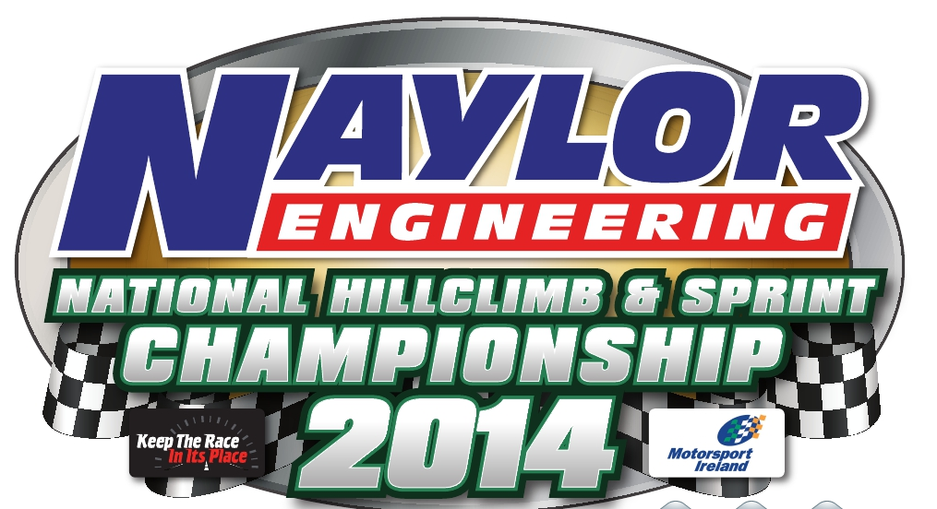
Competition Numbers
Number must be clearly visible on both sides of the car. Registered Hillclimb & Sprint competitors are asked to state on their entry form their registered number. Non registered competitors will be provided with a number by the organizers. Only the race number that you are running with on the weekend of the event is to be visible on your car all other numbers are to be covered up or removed. The onus is on double drivers to make sure that the correct number is on the car before they get to the start line.
Paddock
No competitor’s cars shall be allowed on any of the paddocks before 7.30 am. on the morning of the hill. There shall be no holding of spaces for any competitors. As you enter the hill you shall pull up behind the first vehicle you see, there shall be marshals observing this rule, you must at all times obey the paddock marshal’s instructions. Double drivers shall be accommodated but will have to make themselves known to the paddock marshal who will have a list of the double drives. Waste bins will be provided in each paddock. A portaloo will be in each paddock.
Practice and timed runs
Each competitor must undertake one practice run and no practice re-runs will be allowed. Each competitor must sign on both days before they will be issued with run tickets – no ticket no run. No competitor will be allowed on the hill after the roads are closed.
Finish
The finish line is indicated by chequered flag boards. After crossing the finishing line competitors must reduce speed as quickly as possible within the distance of the 3-2-1 boards.
Awards
F.T.D. overall each day
1st, 2nd, 3rd in class each day
1st, 2nd, 3rd ladies awards each day
F.T.D. overall for the weekend
The Michael Doyle Cup, presented to the highest place Wexford Club member not receiving any other award on the Saturday Hill.
Prize Giving
Saturday’s prize giving will take place in TBA……………at. T.b.A
Sunday’s prize giving will take place in the paddock 30 mins after the
last car Weather Permitting

Final Instructions
Final instructions will be available on line at www.wexfordmotorclub.ie and will also be sent to competitors in a text message, so please remember to include your mobile phone number in your entry form.


www.wexfordmotorclub.ie

Wexford Hillclimb Weekend
12th & 13th April
Rounds 1 & 2 of the
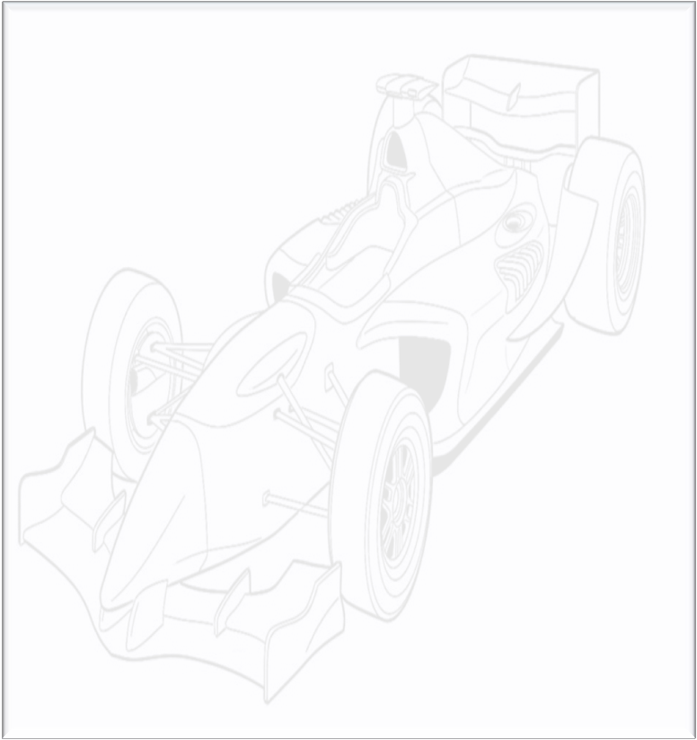
Naylor Engineering
Hillclimb & Sprint Championship 2014
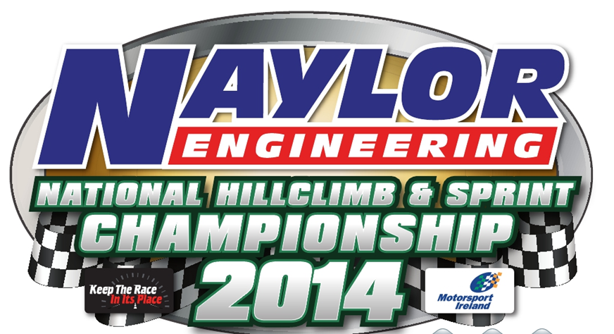
For the Frank Keane Trophy

