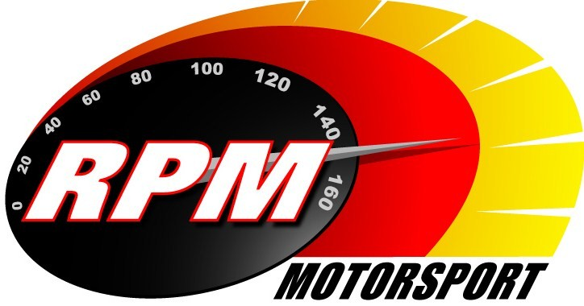
TV BILLINGS May 2013
Ireland’s Leading Motorsports Programme

UTV - Thursday 2nd May - 11.00pm.* - RPM Superbikes - Adelaide Masters Series Supersport 600
Karen Feeney presents the Supersport 600 highlights from the first Adelaide Masters motorcycle meeting of the season at Mondello Park. Jim Halligan, George McCann and Barry Symmons report.

TG4 – Wednesday 8th May – 11.00pm. – Adelaide Masters Series - Superbikes
Karen Feeney presents the Superbike highlights from the first Adelaide Masters motorcycle meeting of the season at Mondello Park. Jim Halligan, George McCann and Barry Symmons report.

UTV - Thursday 9th May - 11.00pm.* - RPM Motorsport - John Mullholland Motors Lark in the Park Rally
Toni Kelly presents the Maiden City Motors Club’s contribution to their City of Culture Year when it brings rallying right into St. Collums Park in the heart of the city. Andrew Bushe, Gary Gillespie, and Alan Tyndall report.

Motors TV, Setanta Sports, Premier TV - From Mon. 13th May – RPM Superbikes - Adelaide Masters Series - Superbikes
Karen Feeney presents the Superbike highlights from the first Adelaide Masters motorcycle meeting of the season at Mondello Park. Jim Halligan, George McCann and Barry Symmons report.

TG4 – Wednesday 15th May – 11.00pm. – Adelaide Masters Series – Supersport 600
Karen Feeney presents the Supersport 600 highlights from the first Adelaide Masters motorcycle meeting of the season at Mondello Park. Jim Halligan, George McCann and Barry Symmons report.

Motors TV, Setanta Sports, Premier TV - From Mon. 20th May – RPM Superbikes -Adelaide Masters Series – Supersport 600
Karen Feeney presents the Supersport 600 highlights from the first Adelaide Masters motorcycle meeting of the season at Mondello Park. Jim Halligan, George McCann and Barry Symmons report.

TG4 – Wednesday 15th May – 11.00pm. – Adelaide Masters Series – Supersport 600
Karen Feeney presents the Supersport 600 highlights from the first Adelaide Masters motorcycle meeting of the season at Mondello Park. Jim Halligan, George McCann and Barry Symmons report.

TG4 – Wednesday 22nd May - 11pm. – Motorsport Ireland - John Mullholland Motors Lark in the Park Rally
Toni Kelly presents the Maiden City Motors Club’s contribution to their City of Culture Year when it brings rallying right into St. Collums Park in the heart of the city. Andrew Bushe, Gary Gillespie, and Alan Tyndall report.

UTV - Thursday 23rd May - 11.00pm.* - RPM Motorsport - Tour of the Sperrins Rally
Toni Kelly presents the round of the Northern Ireland Rally Championship organized by the Magherafelt Motor Club that races through the picturesque Sperrin Mountains. Andrew Bushe, Gary Gillespie, and Alan Tyndall report.

TG4 – Wednesday 29th May - 11pm. - Motorsport Ireland – Tour of the Sperrins Rally
Toni Kelly presents the round of the Northern Ireland Rally Championship organized by the Magherafelt Motor Club that races through the picturesque Sperrin Mountains. Andrew Bushe, Gary Gillespie, and Alan Tyndall report.

*Check with local papers for late schedule changes.

For further information contact:-
Alan Tyndall, Tyndall Productions 58 Edentrillick Road Hillsborough BT26 6PG. Tel 02892 689444. E-mail paul@rpm-motorsport.com

