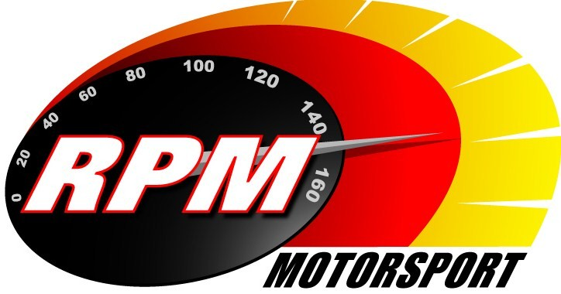
TV BILLINGS April 2013
Ireland’s Leading Motorsports Programme

UTV - Thursday 11th April - 11.00pm.* - Triton Easter Stages Rally I
Toni Kelly Presents the first of two highlight programmes on the Easter Stages Rally, the national event that is a qualifying round of the Irish Tarmac Rally Championship and replaces the Circuit of Ireland Rally this year. Andrew Bushe, Gary Gillespie, and Alan Tyndall report.

TG4 – Wednesday 17th April - 11pm. – Motorsport Ireland – Triton Easter Stages Rally I
Toni Kelly Presents the first of two highlight programmes on the Easter Stages Rally, the national event that is a qualifying round of the Irish Tarmac Rally Championship and replaces the Circuit of Ireland Rally this year. Andrew Bushe, Gary Gillespie, and Alan Tyndall report.

UTV - Thursday 18th April - 11.00pm.* - Triton Easter Stages Rally II
Toni Kelly Presents the second highlight programme on the Easter Stages Rally, the national event that is a qualifying round of the Irish Tarmac Rally Championship and replaces the Circuit of Ireland Rally this year. Andrew Bushe, Gary Gillespie, and Alan Tyndall report.

Motors TV, Setanta Sports, Premier TV. From Mon. 22nd. April – Triton Easter Stages Rally II
Toni Kelly Presents the second highlight programme on the Easter Stages Rally, the national event that is a qualifying round of the Irish Tarmac Rally Championship and replaces the Circuit of Ireland Rally this year. Andrew Bushe, Gary Gillespie, and Alan Tyndall report.

TG4 – Wednesday 24th April - 11pm. – Triton Easter Stages Rally II
Toni Kelly Presents the second highlight programme on the Easter Stages Rally, the national event that is a qualifying round of the Irish Tarmac Rally Championship and replaces the Circuit of Ireland Rally this year. Andrew Bushe, Gary Gillespie, and Alan Tyndall report.

UTV - Thursday 25th April - 11.00pm.* - Adelaide Masters Superbikes
Karen Feeney Presents the Superbike action form Mondello Park where a new season of Ireland’s premier bike racing series gets underway. Jim Halligan, George McCann, and Barry Symmons report.

Motors TV, Setanta Sports, Premier TV. From Mon. 29th April – Triton Easter Stages Rally II
Toni Kelly Presents the second highlight programme on the Easter Stages Rally, the national event that is a qualifying round of the Irish Tarmac Rally Championship and replaces the Circuit of Ireland Rally this year. Andrew Bushe, Gary Gillespie, and Alan Tyndall report.

*Check with local papers for late schedule changes.

For further information contact:-
Alan Tyndall, Tyndall Productions 58 Edentrillick Road Hillsborough BT26 6PG. Tel 02892 689444. E-mail paul@rpm-motorsport.com

