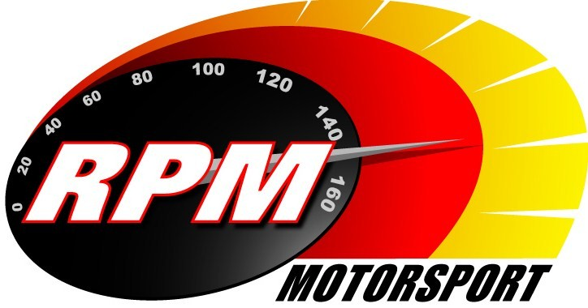
TV BILLINGS - OCTOBER 2012
Ireland’s Leading Motorsports Programme

TG4 – Wednesday 3rd October – 11.00pm * Motorsport Ireland – IRC Romanian & Czech Republic Rallies
Toni Kelly presents an update on the Intercontinental Rally Challenge. Alan Tyndall & Gary Gillespie report.

Setanta – Monday 8th October – 11.00pm * IRC Romanian & Czech Republic Rallies
Toni Kelly presents an update on the Intercontinental Rally Challenge. Alan Tyndall & Gary Gillespie reports.
.
TG4 – Wednesday 10th October – 11.00pm. * Motorsport Ireland – IRC Ukraine Rally
Action from the latest round of the Intercontinental Rally Challenge. Gary Gillespie reports.

UTV - Thursday 11th. October - 11.05pm.* IRC Ukraine & Bulgaria Rallies
Toni Kelly presents an update on the Intercontinental Rally Challenge. Alan Tyndall & Gary Gillespie report.

Setanta – Monday 15th October – 11.00pm.* IRC Ukraine Rally
Action from the latest round of the Intercontinental Rally Challenge. Gary Gillespie reports.

TG4 – Wednesday 17^{d} October – 11.00pm. * Motorsport Ireland – IRC Bulgaria Rally
Action from the latest round of the Intercontinental Rally Challenge. Alan Tyndall reports.

UTV - Thursday 18th. October - 11.00pm * Orchard Motorsport Cork 20 Rally
Highlights from the final round of the Irish Tarmac Rally Championship, where Darren Gass and Garry Jennings are battling it out to become the 2012 Irish Tarmac Rally Champion. Andrew Bushe, Gary Gillespie, and Alan Tyndall report.

Setanta – Monday 22nd October – 11.00pm. * IRC Bulgaria Rally
Action from the latest round of the Intercontinental Rally Challenge. Alan Tyndall reports.

TG4 – Wednesday 24th. October - 11.00pm * Motorsport Ireland - Orchard Motorsport Cork 20 Rally
Highlights from the final round of the Irish Tarmac Rally Championship, where Darren Gass and Garry Jennings are battling it out to become the 2012 Irish Tarmac Rally Champion. Andrew Bushe, Gary Gillespie, and Alan Tyndall report.

Motors TV, Setanta, Premier TV - From Mon. 29th. October Orchard Motorsport Cork 20 Rally
Highlights from the final round of the Irish Tarmac Rally Championship, where Darren Gass and Garry Jennings are battling it out to become the 2012 Irish Tarmac Rally Champion. Andrew Bushe, Gary Gillespie, and Alan Tyndall report.

UTV - Thursday 25th. October - 11.05pm. – Adelaide Masters Superbike Series - Mondello
This 1 hour RPM special covers the Superbike and Supersports 600 races from the final round of Ireland’s premier motorcycle racing series. Karen Feeney presents and Barry Symmons, Jim Halligan and George McCann report.

Motors TV, Setanta – from Monday 29th. October – Adelaide Masters Superbike Series - Mondello
This 1 hour RPM special covers the Superbike and Supersports 600 races from the final round of Ireland’s premier motorcycle racing series. Karen Feeney presents and Barry Symmons, Jim Halligan and George McCann report.

*Check with local papers for late schedule changes.

For further information contact:- Paul McAuley Tyndall Productions 58 Edentrillick Road Hillsborough BT26 6PG. Tel 02892 689444. E-mail paul@rpm-motorsport.com

