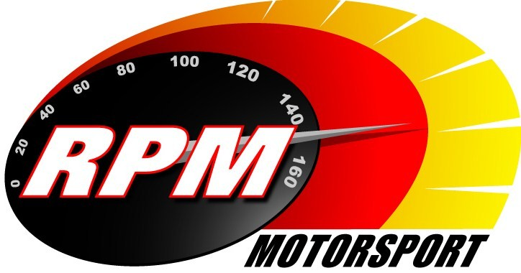
TV BILLINGS - SEPTEMBER 2012
Ireland’s Leading Motorsports Programme

TG4 – Wednesday 5th. September – 11.00pm. Motorsport Ireland – Todds Leap Ulster I
The Irish Tarmac Rally & British Championship action from the penultimate round of Ireland’s premier series. Presented by Toni Kelly with Andrew Bushe, Gary Gillespie, and Alan Tyndall reporting.

UTV - Thursday 6th. September - 11.05pm.* Todds Leap Ulster International Rally II
The Historic and National rally action from the penultimate round of Ireland’s premier series. Presented by Toni Kelly with Andrew Bushe, Gary Gillespie, and Alan Tyndall reporting.

Motors TV, Setanta Sports, Premier TV, Star TV From Mon. 10th. September. - Todds Leap Ulster I
The Irish Tarmac Rally & British Championship action from the penultimate round of Ireland’s premier series. Presented by Toni Kelly with Andrew Bushe, Gary Gillespie, and Alan Tyndall reporting.

TG4 – Wednesday 12th. September – 11.00pm. Motorsport Ireland – Todds Leap Ulster International Rally II
The Historic and National rally action from the penultimate round of Ireland’s premier series. Presented by Toni Kelly with Andrew Bushe, Gary Gillespie, and Alan Tyndall reporting.

UTV - Thursday 13th. September - 11.05pm. - Adelaide Masters Superbike Series - Bishopscourt
Ireland’s Premier Motorcycle Racing series pays its first visit to the County Down circuit. This 1 hour RPM special covers the Superbike and Supersports 600 races. Karen Feeney presents and Barry Symmons, and George McCann report.

Motors TV, Setanta Sports, Premier TV - From Mon. 17th. September.- Todds Leap Ulster International Rally II
The Historic and National rally action from the penultimate round of Ireland’s premier series. Presented by Toni Kelly with Andrew Bushe, Gary Gillespie, and Alan Tyndall reporting.

TG4 – Wednesday 19th. September – 11.00pm. Motorsport Ireland – Orchard Motorsport Lurgan Park Rally
Toni Kelly presents the highlights for Ireland’s foremost single-venue event. Gary Gillespie and Alan Tyndall report.

UTV - Thursday 20th. September - 11.05pm. – Adelaide Masters Superbike Series - Mondello
This 1 hour RPM special covers the Superbike and Supersports 600 races from the fourth round of Ireland’s premier motorcycle racing series. Karen Feeney presents and Barry Symmons, Jim Halligan and George McCann report.

UTV - Thursday 27th. September - 11.05pm.* IRC Romanian & Chech Republic Rallies
Toni Kelly Presents an update on the Intercontinental Rally Challenge. Alan Tyndall reports.

*Check with local papers for late schedule changes.

For further information contact:- Paul McAuley Tyndall Productions 58 Edentrillick Road Hillsborough BT26 6PG. Tel 02892 689444. E-mail paul@rpm-motorsport.com

