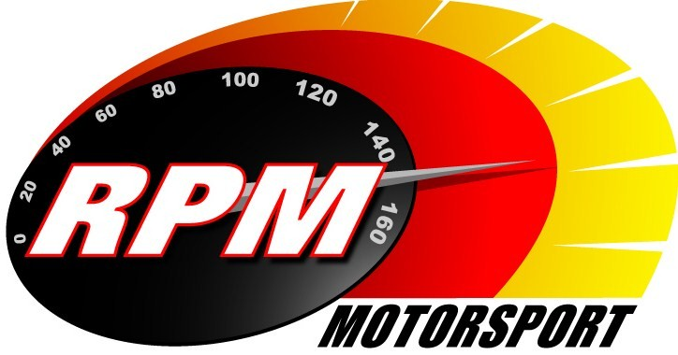
TV BILLINGS - AUGUST 2012
Ireland’s Leading Motorsports Programme

TG4 – Wednesday 1st. August – 11.00pm. Motorsport Ireland – Topaz Donegal International Rally III
Toni Kelly Presents the Modified action from the fourth round of the Irish Tarmac Rally Championship. Andrew Bushe, Gary Gillespie, and Alan Tyndall report.

Motors TV, Setanta Sports, Premier TV From Mon. 6th. August. - Topaz Donegal International Rally III
Toni Kelly Presents the Modified action from the fourth round of the Irish Tarmac Rally Championship. Andrew Bushe, Gary Gillespie, and Alan Tyndall report.

TG4 – Wednesday 8th. August – 11.00pm. Motorsport Ireland – IRC Targa Floria Rally
A review of the Sicilian round of the Intercontinental Rally Challenge, for Super 2000 cars.

UTV - Thursday 9th. August - 11.05pm. - IRC Targa Floria, Ypres, & San Marino Rallies
A review of the Sicilian, Belgium, and Italian rounds of the Intercontinental Rally Challenge, for Super 2000 cars.

TG4 – Wednesday 15th. August – 11.00pm. Motorsport Ireland – IRC Ypres Rally
A review of the Belgium round of the Intercontinental Rally Challenge, for Super 2000 cars.

Setanta Sports - From Mon. 20th. August.- IRC Ypres Rally
A review of the Belgium round of the Intercontinental Rally Challenge, for Super 2000 cars.

TG4 – Wednesday 22nd. August – 11.00pm. Motorsport Ireland – IRC San Marino Rally
A review of the Italian round of the Intercontinental Rally Challenge, for Super 2000 cars.

UTV - Thursday 23rd. August - 11.05pm. –* Lurgan Park Rally
Toni Kelly presents the highlights for Ireland’s foremost single-venue event.
Gary Gillespie and Alan Tyndall report.

Setanta Sports - From Mon. 27th. August.- IRC San Marino Rally
A review of the Italian round of the Intercontinental Rally Challenge, for Super 2000 cars.

UTV - Thursday 30th. August - 11.05pm.* Todds Leap Ulster International Rally I
Toni Kelly Presents the highlights of the opening stages of the fifth round of the Irish Tarmac Rally Championship. Andrew Bushe, Gary Gillespie, and Alan Tyndall report.

*Check with local papers for late schedule changes.

For further information contact:-
Paul McAuley Tyndall Productions 58 Edentrillick Road Hillsborough BT26 6PG. Tel 02892 689444. E-mail paul@rpm-motorsport.com

