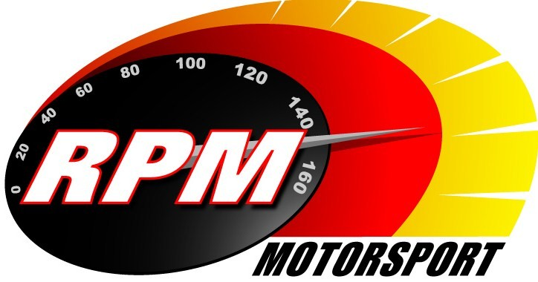
TV BILLINGS - JUNE-JULY 2012
Ireland’s Leading Motorsports Programme

Motors TV, Setanta Sports, Premier TV - From Mon. 4th. June. Cartell.ie Killarney Rally of the Lakes I
Toni Kelly Presents the highlights of the first days action on the third round of the Irish Tarmac Rally Championship. Andrew Bushe, Gary Gillespie, and Alan Tyndall report.

TG4 – Wednesday 6th. June – 11.00pm. Motorsport Ireland – Cartell.ie Killarney Rally of the Lakes II
Toni Kelly Presents the highlights of the second days action on the third round of the Irish Tarmac Rally Championship. Andrew Bushe, Gary Gillespie, and Alan Tyndall report.

UTV - Thursday 7th. June - 11.05pm.* IRC Tour de Corse - Corsica
Craig Breen and Marty McCormick are the Irish representatives in the fourth round of the Inter Continental Rally Challenge on the beautiful island of Corsica. Alan Tyndall reports.

Motors TV, Setanta Sports, Premier TV - From Mon. 11th. June Cartell.ie Killarney Rally of the Lakes II
Toni Kelly Presents the highlights of the second days action on the third round of the Irish Tarmac Rally Championship. Andrew Bushe, Gary Gillespie, and Alan Tyndall report.

Setanta Sports – From Mon. 18th. June - 11.05pm.* IRC Tour de Corse - Corsica
Craig Breen and Marty McCormick are the Irish representatives in the fourth round of the Inter Continental Rally Challenge on the beautiful island of Corsica. Alan Tyndall reports.

UTV - Thursday 21st. June - 11.05pm.* Ards Festival of Speed
Toni Kelly and Karen Feeney present a wide variety of two and four wheeled motorsporting events including drag racing, sprinting, drifting and aerial displays from Newtownards airport.

UTV - Thursday 28th. June - 11.05pm.* Topaz Donegal International Rally I
Toni Kelly Presents the highlights of the opening stages of the fourth round of the Irish Tarmac Rally Championship. Andrew Bushe, Gary Gillespie, and Alan Tyndall report.

Motors TV, Setanta Sports, Premier TV - From Mon. 2nd. July Ards Festival of Speed
Toni Kelly and Karen Feeney present a wide variety of two and four wheeled motorsporting events including drag racing, sprinting, drifting and aerial displays from Newtownards airport.

TG4 – Wednesday 4th. July - 11.00pm.* Motorsport Ireland - Topaz Donegal International Rally I
Toni Kelly Presents the highlights of the opening stages of the the fourth round of the Irish Tarmac Rally Championship. Andrew Bushe, Gary Gillespie, and Alan Tyndall report.

UTV - Thursday 5th. July - 11.05pm.* Topaz Donegal International Rally II
Toni Kelly Presents the highlights of the concluding stages of the fourth round of the Irish Tarmac Rally Championship. Andrew Bushe, Gary Gillespie, and Alan Tyndall report.

Motors TV, Setanta Sports, Premier TV - From Mon. 9th. July Topaz Donegal International Rally I
Toni Kelly Presents the highlights of the opening stages of the fourth round of the Irish Tarmac Rally Championship. Andrew Bushe, Gary Gillespie, and Alan Tyndall report.
TG4 – Wednesday 11th. July - 11.00pm.* Motorsport Ireland - Topaz Donegal International Rally II
Toni Kelly Presents the highlights of the concluding stages of the fourth round of the Irish Tarmac Rally Championship. Andrew Bushe, Gary Gillespie, and Alan Tyndall report.
-2-

UTV - Thursday 12th. July - 11.05pm.* Topaz Donegal International Rally III
Toni Kelly Presents the Modified action from the fourth round of the Irish Tarmac Rally Championship. Andrew Bushe, Gary Gillespie, and Alan Tyndall report.

Motors TV, Setanta Sports, Premier TV - From Mon. 16th. July Topaz Donegal International Rally II
Toni Kelly Presents the highlights of the concluding stages of the fourth round of the Irish Tarmac Rally Championship. Andrew Bushe, Gary Gillespie, and Alan Tyndall report.

UTV - Thursday 19th. July - 11.05pm.* Adelaide Masters Irish Superbikes II
Karen Feeney introduces highlights from the Superbike & Supersports races at the second Adelaide Masters meeting of the year at Mondello Park. Jim Halligan, Barry Symmons, and George McCann report.

Motors TV, Setanta Sports, Premier TV - From Mon. 23rd. July - 11.05pm.* Adelaide Masters Irish Superbikes II
Karen Feeney introduces highlights from the Superbike & Supersports races at the second Adelaide Masters meeting of the year at Mondello Park. Jim Halligan, Barry Symmons, and George McCann report.

*Check with local papers for late schedule changes.

For further information contact:-
Paul McAuley Tyndall Productions 58 Edentrillick Road Hillsborough BT26 6PG. Tel 02892 689444. E-mail paul@rpm-motorsport.com

