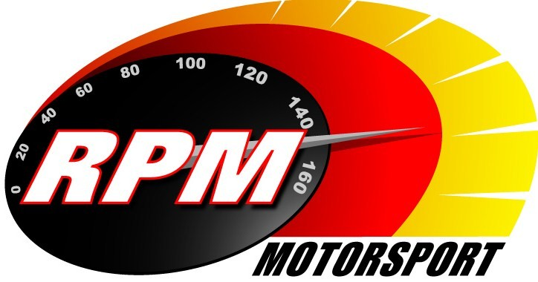
TV BILLINGS April 2012
Ireland’s Leading Motorsports Programme

Motors TV, Setanta Sports, Premier TV From Mon. 9th April – Circuit of Ireland Preview
Toni Kelly presents a preview of the famous Easter rally, which this year is a round of the Intercontinental Rally Challenge (IRC) and the Irish Tarmac Rally Championship. The programme includes highlights from the Azores & Grand Canaries rounds of the IRC and route details of the 2012 event. Andrew Bushe, Gary Gillespie, and Alan Tyndall report.

TG4 – Wednesday 11th April - 11pm. – Motorsport Ireland – Circuit of Ireland Preview
Toni Kelly presents a preview of the famous Easter rally, which this year is a round of the Intercontinental Rally Challenge (IRC) and the Irish Tarmac Rally Championship. The programme includes highlights from the Azores & Grand Canaries rounds of the IRC and route details of the 2012 event. Andrew Bushe, Gary Gillespie, and Alan Tyndall report.

UTV - Thursday 19th April - 11.00pm.* - Donnelly Group Circuit of Ireland Rally I
Toni Kelly Presents the highlights of the first days action on the Donnelly Group Circuit of Ireland Rally a qualifying round for the Intercontinental Rally Challenge (IRC), and the Irish Tarmac Rally Championship. Andrew Bushe, Gary Gillespie, and Alan Tyndall report.

TG4 – Wednesday 25th April - 11pm. – Motorsport Ireland – Circuit of Ireland Rally I
Toni Kelly Presents the highlights of the first days action on the Donnelly Group Circuit of Ireland Rally a qualifying round for the Intercontinental Rally Challenge (IRC), and the Irish Tarmac Rally Championship. Andrew Bushe, Gary Gillespie, and Alan Tyndall report.

UTV - Thursday 26th April - 11.00pm.* - Donnelly Group Circuit of Ireland Rally II
Toni Kelly Presents the highlights of the final days action on the Donnelly Group Circuit of Ireland Rally a qualifying round for the Intercontinental Rally Challenge (IRC), and the Irish Tarmac Rally Championship. Andrew Bushe, Gary Gillespie, and Alan Tyndall report.

Motors TV, Setanta Sports, Premier TV From Mon. 30th April – Circuit of Ireland Rally I
Toni Kelly Presents the highlights of the first days action on the Donnelly Group Circuit of Ireland Rally a qualifying round for the Intercontinental Rally Challenge (IRC), and the Irish Tarmac Rally Championship. Andrew Bushe, Gary Gillespie, and Alan Tyndall report.

*Check with local papers for late schedule changes.

For further information contact:-
Paul McAuley Tyndall Productions 58 Edentrillick Road Hillsborough BT26 6PG. Tel 02892 689444. E-mail paul@rpm-motorsport.com

