Abbey Hotel

CONFERENCE & LEISURE CENTRE
The Diamond, Donegal Town, Co. Donegal.
Tel 00 353 (0)74 9721014
Email info@abbeyhoteldonegal.com

Donegal Forest Stages Rally
Saturday 28th January 2012

Regulations

- Counting Round of the Bassett’s Plumbing & Heating Donegal Motor Club Championship

- Round 1 Valvoline/Motorsport Ireland National Forestry Rally Championship

Rally Headquarters

Abbey Hotel, The Diamond, Donegal Town, Co. Donegal

E-mail eileendelkelly@eircom.net

Website www.donegalmotorclub.com

Organised & Promoted by Donegal Motor Club Ltd

0.1. The DONEGAL FOREST STAGES RALLY is promoted and organised by the Donegal Motor Club Ltd (hereafter known as the promoters).

0.2. The rally is a qualifying round of the Donegal Motor Club Bassett’s Plumbing & Heating Championship and the Valvoline/Motorsport Ireland National Forest Rally Championship 2012.

0.3. These Regulations have been submitted to and approved by Motorsport Ireland and the necessary permit for the holding of the Competition has been granted.

0.4 PERMIT NO: 12/009

ARTICLE 1

1.1. The competition will be held under the International Sporting Code of the F.I.A. and the General Competition Rules of Motorsport Ireland including Appendix 25, 29 and 32 of 2012 yearbook, these Supplementary Regulations Valvoline/Motorsport Ireland National Forest Rally Championship Regulations. All Competitors who forward completed entry forms agree to be bound by these rules.

ARTICLE 2

2.1. The Supplementary Regulations for the rally are as stated by the Motorsport Ireland 2012 Yearbook and Valvoline/Motorsport Ireland National Forest Championship Regulations also in the 2012 Year Book

2.2. Final Instructions form an integral part of the Supplementary Regulations.

ARTICLE 3

3.1. The Use of the Forestry lands for testing or practicing is prohibited, anyone found doing so on the stages to be used for the event will be refused a start and reported to Motorsport Ireland. All named officials are judges of fact in this regard.

ARTICLE 4

4.1. Safety notes will be allowed on this event. Competitors will not be allowed Recce the stages before the event.

  - Safety Notes will be available from third parties on Friday 21st January 2012. If you wish a DVD and your Notes can be ordered. The Club has no involvement in their preparation or sale and accepts no responsibility for their accuracy.

ARTICLE 5

5.1. Entries open on publication of the Regulations.

5.2. All entries must be made on the Official entry form, properly completed and posted with entry fee to:
Eileen Kelly
Stragraddy
Termon
Letterkenny
Co Donegal
E-Mail eileendelkelly@eircom.net
Telephone 00 353 86 8945800 (after 18.00 only please Mon-Fri, anytime Sat/Sun)

5.3. Entry Fee: - €495.00 (Junior €475.00)

5.4. This fee includes Standard IRDS, Personal Accident Insurance, Championship
Registration Fee and Forest Repair Fund.

5.5. All entries to be paid in Euro Currency ONLY

5.6. Cheques should be made payable to Donegal Motor Club Ltd.

NO LICENCE – NO START
NO IRDS LETTER OR NO BRDS – NO START

ARTICLE 6
MI Steward | Sean Mc Hugh | Equipment Officer | Albert Moore
MI Safety Officer | Paul Kiely | PRO & Press Officer | Declan Mc Cay
COC | Michael Kelly | Chief Scrutineer | Alan Redstone
Deputy COC | Danny Gormley | Chief-Timekeeper | Elizabeth Devine
Deputy COC | Larry Harper | Spectator Control | Leonard Wilson
Assistant COC | Paul Lyons | Chief Medical Officer | Pauric Conneally
Assistant COC | Tony Boyle | Rescue | Athlone Rally Rescue
DMC Safety Officer | Patrick Haughey | Chief Rescue Officer | Frank Heneghan
Secretary of the Event | Eileen Kelly | Results Officer | Patrick Mc Collum
DMC Club Steward | Kieran Doherty | Service Manager | Johnny Pollock
CLO | Philip Nicholson | Radio Controller | TBA
Stage Commanders | Tony O’Brian | Communications | Grannia Mc Elhinney
Stage Commanders | Tommy Doherty | Car Accountability | Joe Breslin
Stage Commanders | John Comiskey | Chief Marshal | Eamonn Mc Gee
Stage Commanders | John Keyes | Serious Incident Off | Attracta Mc Cay
DMC Fire Officer | Kieran Breslin

ARTICLE 7

Class 1 Cars up to 1450cc (see note 1)

Class 2 Cars from 1451cc to 1650cc, with only 2 valves per cylinder( see note 1)

Class 3 Cars from 1451cc to 1650cc, with more than 2 valves per cylinder (see note 1)

Class 4 Cars from 1651cc to 2100cc with 2 valves only per cylinder (see note 1)

Class 5 Cars 2101cc to 3500cc, including all two wheel drive cars with more than 2 valves per cylinder over 1651cc, V8’s normally aspirated (see note 1)

Class 6 4wd Four wheel drive cars excluding all WRC cars in this class must comply with
their last published homologation papers, FIA Appendix J including:-
Metro 6R4’s as per Group B 2777 homologation papers and the following; maximum 2800cc, with 65mm plenum restrictor or 2500cc with trumpeted induction and must run with MSA certified engine only. The engine certificate must be presented to each event Scrutineer.
Subaru Legacy Homologation Nos. A5399 and N5399 may be fitted with a Turbo
charger fitted normally to Subaru Impreza and complying with Homologation No.
A5480 or N5480.
Ford Escort RS Cosworth, homologation No. A5466 and Ford Sierra Cosworth 4x4
homologation number A5414 may run with non homologated gearbox. No other
modifications are permitted and the car must comply with the homologation papers.
Additional cars authorised at the discretion of Motorsport Ireland in advance may also be allowed to enter this class but must not exceed 3500cc

Class 7 All WRC cars only, must comply with last published Group A homologation papers F.I.A. appendix J.

Class 8 Group N, Four wheel drive complying with their last published homologation papers as per FIA Appendix J.

Class 9 Junior Class: This class is open to drivers born on or after 01.01.1986, driving cars up to 1650cc, 2 wheel drive, normally aspirated.

Class 10 R2 homologated cars

Class 11 Historic Cars

The onus is at all times on the entrant/competitor to enter the correct class.

See Appendix 32 of the 2012 Motorsport Ireland Year Book, for class notes and Championship Regulations 2012

ARTICLE 8

Awards shall be awarded to both the Driver & Co-Driver in the following classifications.

- 1st, 2nd, 3rd Overall
- 1st, 2nd, 3rd in each class
- Best DMC Crew
- Highest Placed Ladies Crew
- Best Junior Crew

Note: No Competitor can win more than 1 award. The club reserves the right to
amalgamate classes if there are insufficient entries. For club member
awards you must comply with club rules to qualify.

ARTICLE 9

Entries Open On Publication of Regulations

Entries Close Friday 20th January 2012

Final Instructions Posted Tuesday 24th January 2012

Mechanical Scrutiny S & R Motors, Ballybofey Road, Donegal Town
Friday 27th January 2012 only from 16.00 to 21.00

Documentation Scrutiny Abbey Hotel, The Diamond, Donegal Town
Friday 27th January 2012 from 16.00 to 21.30

Parc Ferme The John Bosco Centre, Donegal Town

Competitors' Safety Briefing (compulsory for all crews)
Abbey Hotel, The Diamond, Donegal Town
08.00 on Saturday 28th January 2012

Parc Ferme Out First Car Due 08.30 28th January 2012

First Car Due Back Abbey Hotel, The Diamond, Donegal Town
18.00 28th January 2012

Provisional Results Posted at the Abbey Hotel
19.00 on Saturday 28th January 2012

Prizegiving Abbey Hotel, The Diamond, Donegal Town
21.30 on Saturday 28th January 2012

Abbey Hotel

CONFERENCE & LEISURE CENTRE
The Diamond, Donegal Town, Co. Donegal.
Tel: 00 353 (0)74 9721014
Email: info@abbeyhoteldonegal.com

Donegal Forest Stages Rally
28th January 2012

Entry Form

- Counting Round of the Bassett’s Plumbing & Heating Donegal Motor Club Championship

- Round 1 Valvoline/Motorsport Ireland National Forestry Rally Championship

Rally Headquarters

Abbey Hotel, The Diamond, Donegal Town, Co. Donegal

E-mail eileendelkelly@eircom.net

Website www.donegalmotorclub.com

Organised & Promoted by Donegal Motor Club Ltd
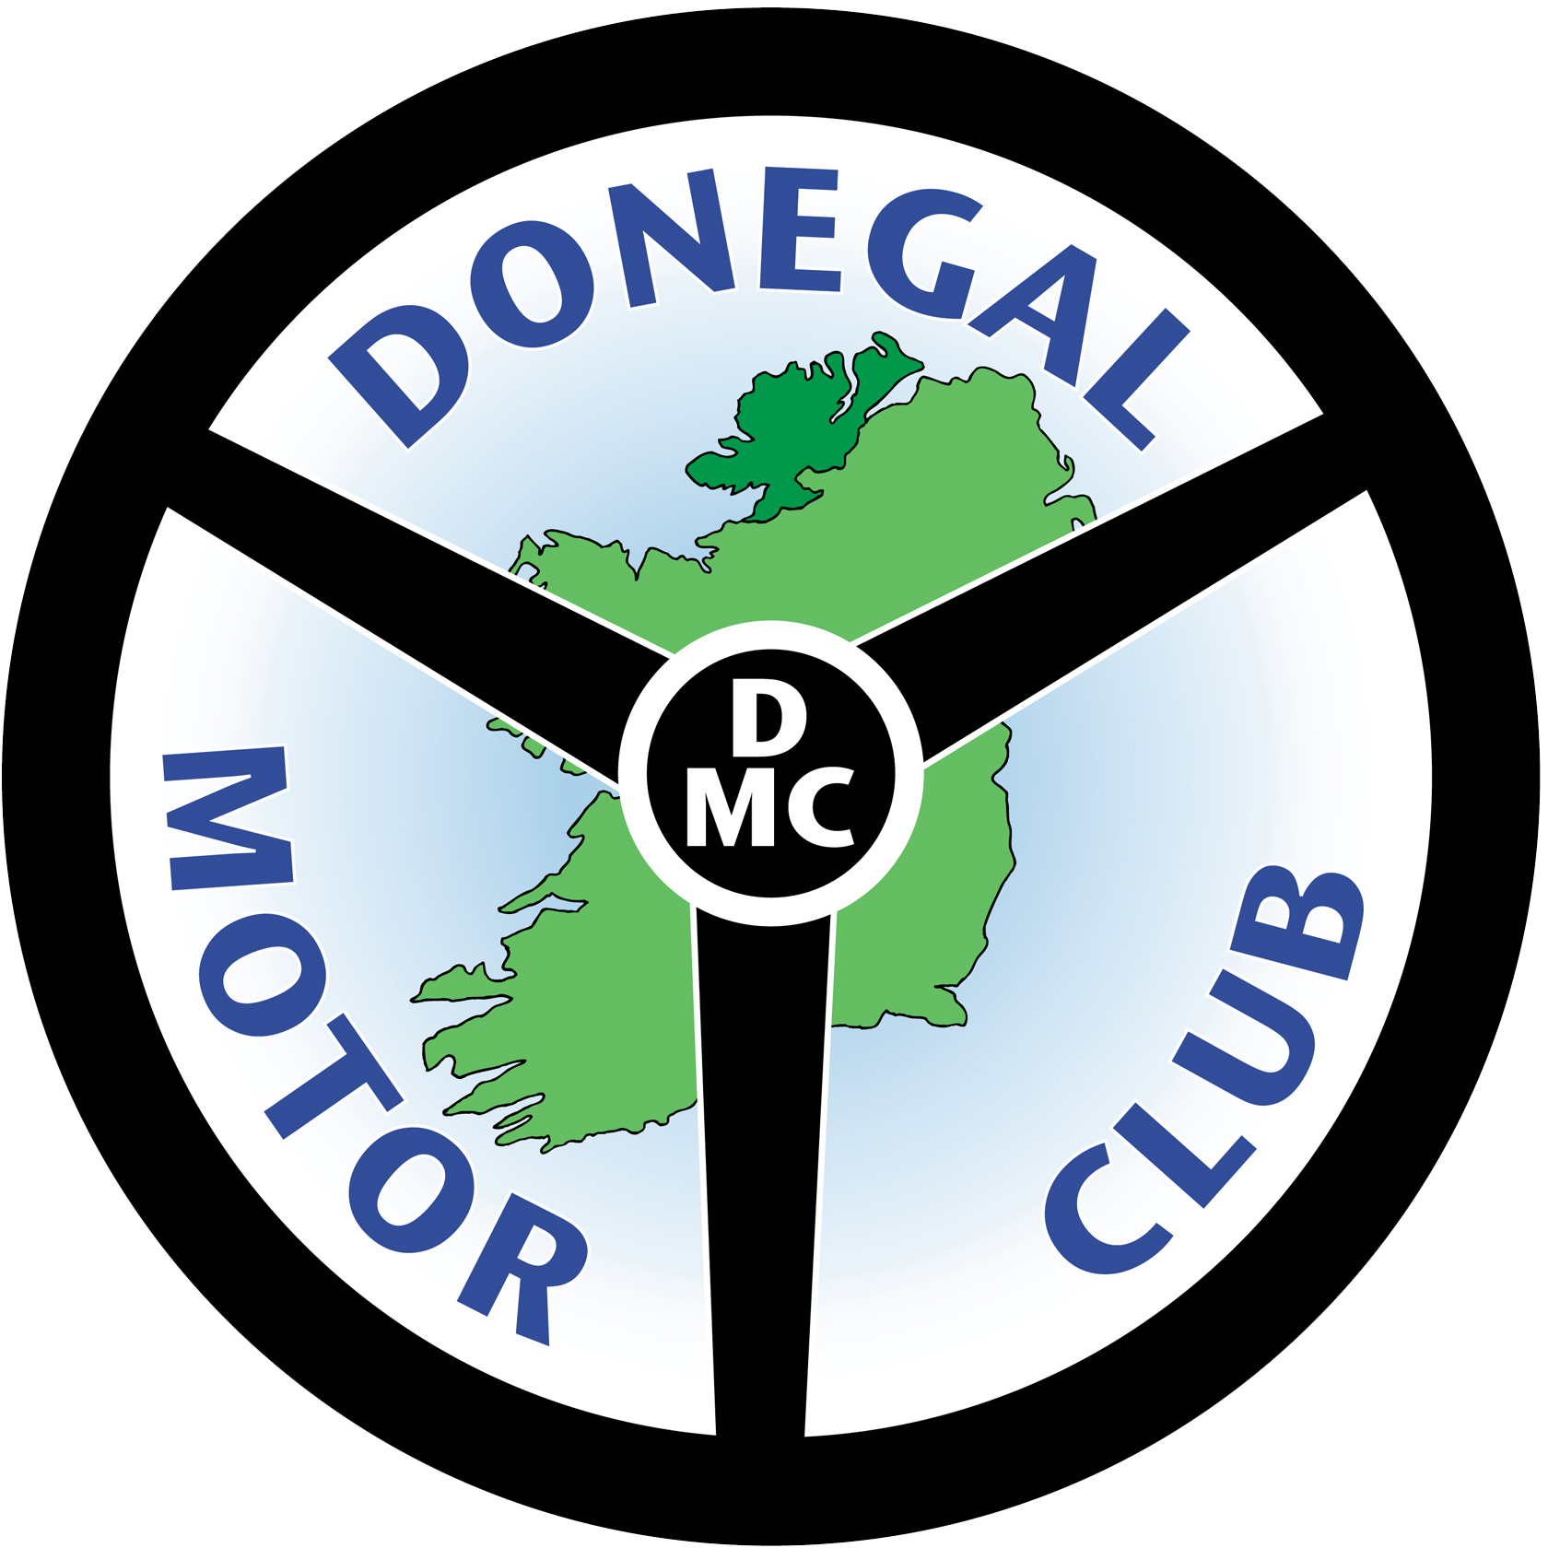DONEGAL MOTOR CLUB FOREST STAGES RALLY ENTRY FORM 2012
Office Use Only Date Received _____________ 2012 ENTRY NO ALLOCATED ______

Please complete in Block Capitals
ENTRANT DETAILS CAR DETAILS
Name _________________________ Make ___________________________
Address _______________________ Model ___________________________
______________________________ Capacity ______________________
______________________________ Year ___________________________
Comp. Lic. No ___________________ Colour ___________________________
Tel No ________________________ Reg No __________________________
E-Mail Address ____________________________________________________________

CLASS ENTERED

DRIVER Name _____________________________________________
Address ____________________________________________________________
_______________________________ IRDS/BRDS No. ____________________
Comp. Lic. No ____________________ Issued by __________________________
Telephone No ____________________ Dgl Motor Club Member (Yes/No) ________

CO-DRIVER Name ____________________________________
Address ____________________________________________________________
_______________________________ IRDS/BRDS No. ____________________
Comp. Lic. No ____________________ Issued by _________________________
Telephone No ____________________ Dgl Motor Club Member (Yes/No) _______

Service Vehicle
Make _________________ Model ______________ Reg No ________________
Person in Charge ___________________ Telephone Number __________________

Where do you think you should be Seeded?
1-20 | 20-40 | 40-60 | 60-80 | 80-100 | Org. Dis.

I wish to be seeded near _______________________________________________
Enter below details of results achieved to date
Event | Year | Overall Position | Class Position | OFFICIAL USE ONLY

DECLARATION OF INDEMNITY

(a) I have read the supplementary regulations issued for this event and agree to be bound by them and by the General Competition Rules and Regulations of MI including the guidelines and regulations contained in Motorsport Ireland’s Code of Conduct for Children’s Sport. In consideration of the acceptance of this entry or of my being permitted to take part in this event I agree to save harmless and keep indemnified the Donegal Motor Club Ltd.(Organising Club), Irish Automobile Club Ltd. t/a Royal Irish Automobile Club, Irish Motorsport Federation Ltd. t/a Motorsport Ireland and their respective officials, servants, representatives and agents from and against all actions, claims, costs, expenses and demands in respect of death, injury, loss of or damage to the person or property of myself, my driver(s), passenger(s) or mechanic(s) (as the case may be) howsoever caused arising out of or in connection with this entry or my taking part in this event and notwithstanding that the same may have been contributed to or occasioned by the negligence of the said bodies, their officials, servants, representatives or agents. Furthermore, in respect of any parts of this event on ground where Third Party Insurance is not required by law, this Agreement shall in addition to the parties named above extend to all and any other competitor(s) and their servants and agents and to all actions, claims, costs, expenses and demands in respect of loss of or damage to the person or property of myself, my driver(s), passenger(s) or mechanic(s).

My age (driver) is __________________ (if applicable, state "over 18 years")
My age (co-driver) is ________________ (if applicable, state "over 18 years")

(b) I declare that to the best of my belief the driver(s), passenger(s) possess the standard of competence necessary for an event of the type to which this entry relates and that the car entered is suitable and roadworthy for the event having regard to the course and the speeds which will be reached.
I declare that the use of the car hereby entered is covered by Insurance as required by the Road Traffic Act, which is valid for such part of this event as shall take place on roads as defined in the Act.

(c) I understand that should I at the time of this event be suffering from any disability whether permanent, temporary or otherwise which is likely to affect prejudicially my normal control of my automobile, I may not take part unless I have declared such disability to MI, who have, following such declaration issued a licence which permits me to do so.

(d) I undertake that at the time of the event to which this entry relates I shall be in possession of a current certificate of medical fitness. In the case of MI Licence Holders, only certificates on the official MI or FIA Medical Forms will be accepted.

(e) Any indemnity and/or declaration as prescribed by sub-paragraphs (a) and (b) above which is signed by a person under the age of 18 years shall be countersigned by that person's parent or guardian, whose full names and address shall be given. Furthermore, the parents and/or guardians of persons under 18 years of age shall grant permission to MI and the Irish Sports Council to carry out tests in accordance with the Irish Anti-Doping Rules (Rule No 139) in the following form:

"I/we hereby grant permission to MI and the Irish Sports Council to carry out tests as set out in Rule No 139 of the GCRs in accordance with the Irish Anti-Doping Rules."

Signatures
Driver ___________________ Date ___/___/2012 Guardian ____________________ Date ___/___/2012

Co-Driver __________________ Date ___/___/2012 Guardian ____________________ Date ___/___/2012

Entrant (If different from driver) ____________________ Date ___/___/2012

Guardian _______________________ Date ___/___2012

Please Note: Any indemnity form and/or declaration prescribed above which is signed by a person under the age of 18 years shall be countersigned by that person's parent or guardian, whose full name and address shall be given.

Organised & Promoted by Donegal Motor Club Ltd.

