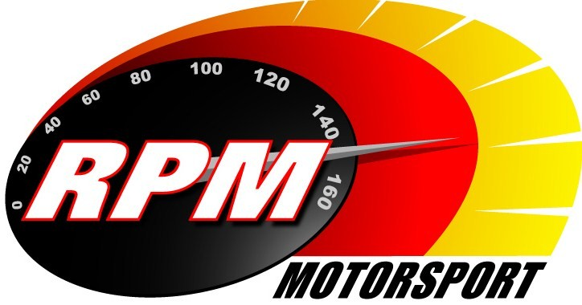
TV BILLINGS May 2011
Ireland’s Leading Motorsports Programme

Setanta Sports, Motors TV – From Monday 2nd. May – Adelaide Insurance Mondello Motorcycle Masters
The new Mondello Motorcycle Masters series featuring the Superbike races from the County Kildare circuit. Jim Halligan & Leo Nulty report.

Setanta Sports, Motors TV – From Monday 9th. May – Adelaide Insurance Mondello Motorcycle Masters
The new Mondello Motorcycle Masters series featuring the Supersports 600 races from the County Kildare circuit. Jim Halligan & Leo Nulty report.

UTV - Thursday 12th. May - 11.10pm.* - Donnelly Group Circuit of Ireland Rally I
The first days action from the second round of the Irish Tarmac Rally Championship, the 80th. Anniversary of the Circuit of Ireland, the country’s most famous rally. Alan Tyndall & Gary Gillespie report.

UTV - Thursday 19th. May - 11.10pm.* - Donnelly Group Circuit of Ireland Rally II
The second days action from the 80th. Anniversary of Ireland’s most famous rally. Alan Tyndall & Gary Gillespie report.

Setanta Sports, Motors TV – From Monday 23rd. May - Donnelly Group Circuit of Ireland Rally I
The first days action from the second round of the Irish Tarmac Rally Championship, the 80th. Anniversary of the Circuit of Ireland, country’s most famous rally. Alan Tyndall & Gary Gillespie report.

UTV - Thursday 26th. May - 11.10pm.* - Killarney Rally of the Lakes
The highlights from the third round of the Irish Tarmac Rally Championship run through the Kerry Mountains. Alan Tyndall & Gary Gillespie report.

Setanta Sports, Motors TV – From Monday 30th. May - Donnelly Group Circuit of Ireland Rally II
The second days action from the second round of the Irish Tarmac Rally Championship. Alan Tyndall & Gary Gillespie report.

*Check with local papers for late schedule changes.

For further information contact:-
Paul McAuley Tyndall Productions 58 Edentrillick Road Hillsborough BT26 6PG. Tel 02892 689444. E-mail paul@rpm-motorsport.com

