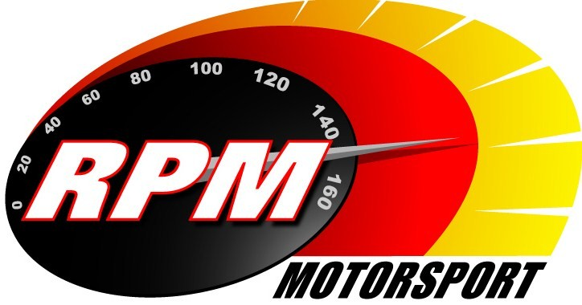
TV BILLINGS April 2011
Ireland’s Leading Motorsports Programme

UTV - Thursday 14th. April - 11.10pm.* - Donnelly Group Circuit of Ireland Rally Preview
A look ahead at the 80th. running of Irelands most famous rally. Alan Tyndall & Gary Gillespie report.

Setanta Sports, Motors TV – From Monday 18^{th.} April – Donnelly Group Circuit of Ireland Rally Preview
A look ahead at the 80th. running of Irelands most famous rally. Alan Tyndall & Gary Gillespie report.

UTV - Thursday 21st. April - 11.10pm.* - Adelaide Insurance Mondello Motorcycle Masters
RPM’s first coverage of the new Mondello Motorcycle Masters series featuring the April Superbike races from the County Kildare circuit. Jim Halligan & Leo Nulty report.

UTV - Thursday 28th. April - 11.10pm.* - Adelaide Insurance Mondello Motorcycle Masters
RPM’s coverage of the new Mondello Motorcycle Masters series featuring the April Supersports 600 races from the County Kildare circuit. Jim Halligan & Leo Nulty report.

*Check with local papers for late schedule changes.

For further information contact:-
Paul McAuley Tyndall Productions 58 Edentrillick Road Hillsborough BT26 6PG. Tel 02892 689444. E-mail paul@rpm-motorsport.com

