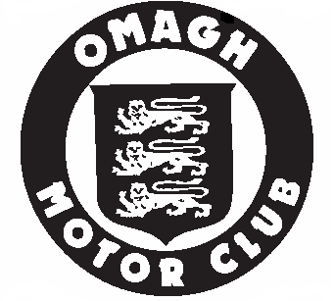
OMAGH MOTOR CLUB LTD.
AIDEN CALDWELL SPRING RALLY 2011

FINAL INSTRUCTIONS 1

- Thank you for your entry which has been accepted.

Your Competition number for the event is (See Entry List)
Door Numbers will Not be supplied
Each competitor must supply their own door numbers

Scrutiny will take place on Saturday 26th February 2010
Scrutiny Times are as follows ;
Cars No. 1- 30 from 7:00am to 8:00am
Cars No. 30 - 60 from 8:00am to 9:00am
Cars No. 60 – 90 from 9.00am to 9:45am
Due to the large number of entries received, these times must be adhered to.

- SCRUTINY will take place at William Bell Tractors, Clabby Road, Fivemiletown (Map of location attached). Vehicles will be checked for conformity with the Road Traffic Order and MSA Regulations with regard to safety and eligibility. Cars which are presented for scrutiny without the relevant DOE Tax book, MSA Log book, current tax disc and MOT or NCT certificate (where applicable) will not be permitted to start. NO EXCEPTIONS. Full size number plates front and rear. Failure to report for scrutiny at the designated time may lead to exclusion

- DOCUMENTATION & SIGNING ON will take place immediately following scrutiny at the Chestnut Bar. A satisfactory scrutiny sheet must be presented together with valid licenses and insurance documents. MSA licences must have a photograph of the holder affixed and must be signed to be deemed valid.

- All persons under 18 must have a parent or guardian present who must countersign.

- The first car will start no earlier than 11.01am on Saturday 26th February 2011. Any competitor not signed on by 10:15 am will be excluded and his/her place taken by a competitor from a reserve list, should one exist, or failing this he/she may be requested to take up a place at the end of the starting list. Individual times for starting will be posted on Saturday morning no later than 10:30 am.

Drivers Briefing at 10:30

- Please note the following amendments to the officials:-
MSA STEWARD – Donald Grieve

- Food will be available on Saturday morning and Saturday evening at the Chestnut Bar, Fivemiletown, please support the rally headquarters.

- The PSNI have been informed of the route and competitors are reminded of their responsibilities on road behavior and speeding.

- The results will be published in the Chestnut Bar, Fivemiletown and the prize-giving will also be at this venue.

- As there is limited space in the service area only one service vehicle per competitor will be granted access. Cars No. 1-30 must go to Fivemiletown High School car park please note this car park will open at 7:00 0am. Groundsheets must be used at all times while in the service area. Any competitor found not using a groundsheet will be excluded.

- A trailer park is available in the Church car park which will be clearly sign posted.

- The use of SOS Boards must be complied with as per 1st page of the Road Book

- The Rally will commence at approx 11.01am.

- Patterson notes have produced Safety notes of the rally route. A copy can be purchased direct from Brian Patterson , contact details as per the regs.

- Ian Connolly has been appointed as the competitor liaison officer. Any and all queries must be presented to Ian at an appropriate time.

- MSA permit number 62826 has been issued for this event.

Thomas Nugent + Ryan Darcy
C.O.C.

