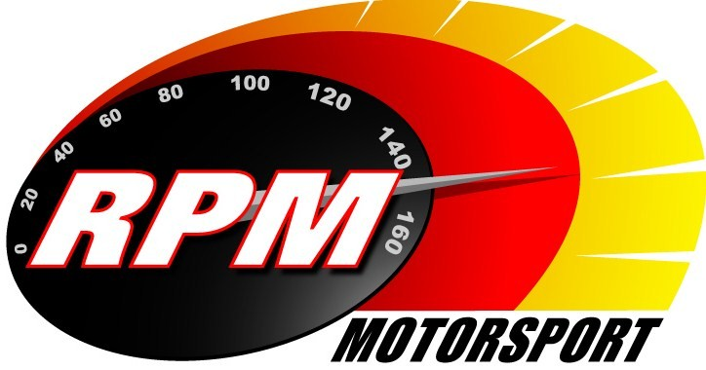
TV BILLINGS February / March 2011
Ireland’s Leading Motorsports Programme

UTV - Thursday 17th. February - 11.10pm.* - Safety Direct Galway International Rally I
The World Rally Car, Group N action from the opening round of the Irish Tarmac Rally Championship. Alan Tyndall & Gary Gillespie report.

UTV - Thursday 24th. February - 11.10pm.* - Safety Direct Galway International Rally II
The Modified and Historic action from the opening round of the Irish Tarmac Rally Championship. Alan Tyndall & Gary Gillespie report.

Setanta Sports, Motors TV – From Monday 28^{th.} February – Safety Direct Galway International Rally I
The World Rally Car, Group N action from the opening round of the Irish Tarmac Rally Championship. Alan Tyndall & Gary Gillespie report.

Setanta Sports, Motors TV – From Monday 8^{th.} March – Safety Direct Galway International Rally II
The Modified and Historic action from the opening round of the Irish Tarmac Rally Championship. Alan Tyndall & Gary Gillespie report.

*Check with local papers for late schedule changes.

For further information contact:-
Paul McAuley Tyndall Productions 58 Edentrillick Road Hillsborough BT26 6PG. Tel 02892 689444. E-mail paul@rpm-motorsport.com

