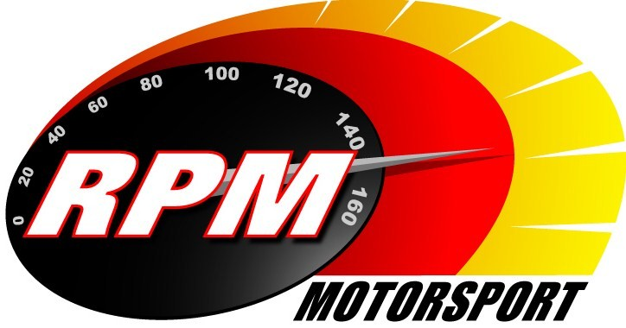
TV BILLINGS JULY / August 2010
Ireland’s Leading Motorsports Programme

JULY

UTV - Thursday 1st. July - 11.10pm.* - Topaz Donegal International Rally I
The World Rally Car, Group N and Two-wheel-drive action from the fourth round of the Citroen Irish Tarmac Rally Championship. Alan Tyndall & Gary Gillespie report.

Setanta Sports, Motors TV – From Monday 5^{th.} July - Modern Tyre Service Mourne Rally II
In the second RPM programme from the fifth round of the Hankook Northern Ireland Stages Championship, the Modified cars and the class leaders come under the spotlight. Alan Tyndall & Gary Gillespie report.

UTV - Thursday 8^{th.} July - 11.10pm.* - Topaz Donegal International Rally II
Donegal traditionally gets the biggest Modified entry of the year, and RPM will be concentrating on the ‘sideways cars’ in programme 2 from the north-west. Alan Tyndall & Gary Gillespie report.

Setanta Sports, Motors TV, Euro, North One, & Star TV – From Monday 12th. July –
Topaz Donegal International Rally I. The Citroen Irish Tarmac Rally Championship moves to the north-west at its half way point. Programme 1 follows the World Rally Car, Group N and two-wheel-drive action. Alan Tyndall & Gary Gillespie report.

Setanta Sports, Motors TV – From Monday 19^{th.} July - Topaz Donegal International Rally II
Donegal traditionally gets the biggest Modified entry of the year, and RPM will be concentrating on the ‘sideways cars’, and the Citroen C2R2 racers in Programme 2 from the north-west. Alan Tyndall & Gary Gillespie report.

AUGUST

UTV - Thursday 5^{th.} August - 11.10pm.* - Paddy Rally.
A fun day out for supercars and personalities, starting from Belfast they travel south to the Mondello International Race Track in County Kildare, and then back north again for a party in County Down. Katie Larmour and Alan Tyndall report.

UTV - Thursday 12^{th.} August - 11.10pm.* - Lurgan Park Rally.
There is big money for the annual big blast through the park in Lurgan, which features WRC, Group N, and a special prize for the Escort Mk II entertainers. Andrew Bushe, Alan Tyndall, and Gary Gillespie report.

Setanta Sports, Motors TV – From Monday 16^{th.} August. - Paddy Rally.
A fun day out for supercars and personalities, starting from Belfast they travel south to the Mondello International Race Track in County Kildare, and then back north again for a party in County Down. Katie Larmour and Alan Tyndall report.

UTV - Thursday 19^{th.} August - 11.10pm.* - Dog Leap Rally.
The RPM cameras go into the forests for the first time this year on the Hankook Northern Ireland Rally series when the Maiden City Motor Club host the sixth round of the championship. Andrew Bushe, Alan Tyndall, and Gary Gillespie report.

-2-

Setanta Sports, Motors TV – From Monday 23rd. August. – Lurgan Park Rally.
There is big money for the annual big blast through the park in Lurgan, which features WRC, Group N, and a special prize for the Escort Mk II entertainers. Andrew Bushe, Alan Tyndall, and Gary Gillespie report.

Setanta Sports, Motors TV – From Monday 30th. August. – Dog Leap Rally.
The RPM cameras go into the forests for the first time this year on the Hankook Northern Ireland Rally series when the Maiden City Motor Club host the sixth round of the championship. Andrew Bushe, Alan Tyndall, and Gary Gillespie report.

*Check with local papers for late schedule changes.

For further information contact:-
Paul McAuley Tyndall Productions 58 Edentrillick Road Hillsborough BT26 6PG. Tel 02892 689444. E-mail paul@rpm-motorsport.com

